Greetings Allisonville Alligators! September 18, 2020

At a special meeting held earlier this week, the School Board voted in favor of re-opening schools in Washington Township starting on Monday, October 12th (grades K-2) and on Monday, October 19th (grades 3-5). We are hard at work at Allisonville to prepare for students to return to in-person instruction. Those who selected to remain virtual will be shifted to the Virtual Academy at Allisonville as well. Families have until Sunday, September 20th to make their final selection. The full re-opening plan can be found on the district’s website and our specific re-opening plan for Allisonville can be found in the Gazette. More detailed information will also be shared in the upcoming days.

This is the last week the Scholastic Book Fair is open so be sure to order any books you would like before Tuesday, September 22nd. Look for additional information in the Gazette on how to order from the Book Fair online. Items will be shipped directly to your home – it is that easy! If you ordered AV Spirit Wear or last year’s Yearbook and have not picked these items up yet, they are also ready for pick up in the front vestibule at Allisonville.

We are excited to celebrate Spirit Week this week at Allisonville! It is Homecoming Week at North Central and although there will be no parade of schools this year at the football game, we can still celebrate our school spirit virtually! Be sure to dress up next week for each of our Spirit Days:
- Monday: Gator Green Day
- Tuesday: Hat Day
- Wednesday: Sports Team Day
- Thursday: Crazy Hair Day
- Friday: Allisonville Spirit Day and Family KAHOOT!
We will also have an early release on Thursday, September 24th so teachers can join professional development meetings. Please note that teachers will not be available after 2:15pm on Thursday. For the final celebration of our Spirit Week, all students are invited to join in an All School Kahoot Game at 3:00 on Friday, September 25th, which will be led by our technology teacher, Mr. Auslander. This is all for fun and to celebrate as a school how great it is to be an Allisonville Alligator!

I can’t wait to see everyone dressed up next week and also at the Kahoot on Friday!

Mrs. Reffett
Principal

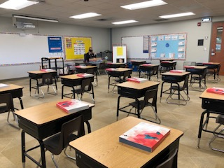
Reopening of School in MSDWT

Thank you for carefully reviewing the following information and completing the new reopening enrollment process based on the current WT Reopening of Schools for In-Person Learning Plan. This information will help us with vital planning and preparation while we await the Board approved COVID-19 data threshold for returning to in-person learning to be met per the plan.

Here are answers to many of the questions that were asked about AV specifically: Re-entry Q&A . A full reopening play can be found on the MSDWT Website.

Mark Your Calendar for these Upcoming Dates
- September 21-25: Spirit Week with Dress Up Days!
- Tuesday, September 22: Book Fair Ends
- Thursday, September 24: Early Release at 2:15 pm
- Friday, September 25: School-Wide Kahoot Game at 3:00
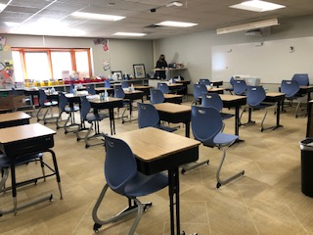
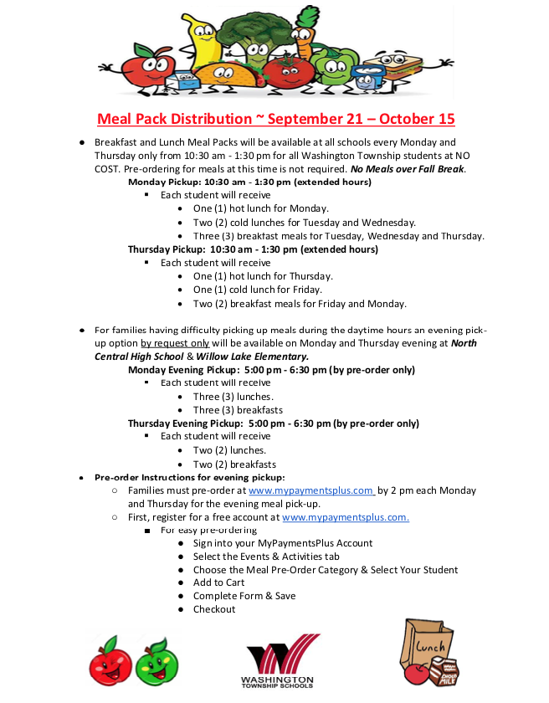
Good news! Allisonville has subscribed to a fun, new reading program that you and your child can access from home! Scholastic BookFlix is an online literacy resource that pairs classic video storybooks from Weston Woods with related nonfiction eBooks from Scholastic to build a love of reading and learning.

To access Bookflix:
Go to Bookflix login page or https://digital.scholastic.com/site/launch/bkflix?ucn=600054245
Username: aville password: 1234

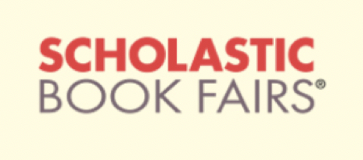

You’re invited to shop our Scholastic Book Fair online from Sept. 9 – 22, 2020! All purchases benefit our school and connect kids with new books, favorite characters, complete series, and more.
You’ll love the NEW option to shop for Book Fair exclusives directly from the interactive booklist and enjoy these special online shopping features:
- Over 6,000 items, including new releases, best sellers, and value packs
- All orders ship direct to home
- FREE shipping on book-only orders over $25*
- All purchases support our school and earn 25% in rewards
Visit our Book Fair Homepage and click “Shop Now” to get started:
https://scholastic.com/bf/allisonvilleelementaryschool

Kindergarten
Alex Chambers
Londyn Hutcherson
George Cheeseborough
Blake Boger
Juan Antunez-Reynoso
Joel Hershey
Julian Shipp
Alex Sulieman
Hashim Maaita
Hannah Henhapl
Claire Ellrich
Arya Ellrich
Anna Williams
Etta Morgan
Jax Bravo
Lillian Partington
Eliza Hastings
Jason Castro
Ximena Hernandez
Aurora Bunch
Max McGinley
Dylan Godinez
Mackenzie Lintern
Kilian Simmons
Henry Gregoire
Kiersa Hughes
Easton Morris
Sybil Horan
Eliza Hastings
Laila Amos
Max McGinley
James Sessa
Beatrix Hensley
Eva Marquez
Murad Abu-Rumman
Lynnox Sparks
Rileigh Reed
Sincere Conley

First Grade
Ta’Ron Taylor
Aria Jackson
Reagan Powell
Lauren Sherer
Umaija Warda
Avery Meares
Chloe Snow
Noli Peters
Aria Jackson
Savi Kennedy
Caroline Lickliter
Quinn McFarlen
Elliette Dillon
Wesley Hershey
Mona Pfaff
Nolan Kepley
Maddie Walters
Simon Kelm
Alanys Diaz
Evan Ekwall
Cohen Mumford
Hailey Herman
Kate Riggers
Ember Glover
Aaliyah Lopez
Vivienne Hood
Caroline Walter
Jack Baldwin
Cara Stocks
Max Mintun
Maya Kolbus
Evan Ekwall
Ember Glover
Hailey Herman
Alanys Diaz
Cohen Mumford
Stella Boyle
Claire Roberts
Reese Younger
William Berger
Vivienne Hood
Luke Kiligrew
Preston Curry
Max Mintun
Doeyun Schwantes-An
Jocelyn Barr
Lucille Rarick
Zaylee Leal-Lopez
Reagan Powell
Tyler Moore
Amir Appleton
Bodie Mosby
Everett Williams
Miles Sanchez

Second Grade
A’Miah Carter
Aria Bolds
Rylee Clemmons
Scarlet Solis Dominguez
Maeve Tuason
Madeline Nash
Charlee Jackson
Hadley Brezette
Cora Deardorff
Asher Hill
Kayden Hodge
Serene Maita
Ruby Crotzer
Owen Whaley
Jackson Wahl
Miles Ruffing
Asher Hill
Melodie Sheppard
Lilliana Kennedy
Walter Lynn
Lyla Zunker
Emma Cordes
Ryan Beeler
Josie Reid
Malcolm Harlan
Karl-Andy Jean
Braydon Rush
Ashton Evers
Aria Gaynor
Natalie Castro
Hudson Henhapl
Marin Sickinger
Jovi
June Morgan
Drew Fields
Natalie Bobay
Nate Kaufman
Walker Brown
Ethan Gouge
Cooper Ball
Abby Hunter
Aaliyah Evens
Clanesky Joseph
Emma Cordes

Third Grade
Ari Ajayi
Kameron Robinson
Harmonie Preswood
Dylan Terry
Adelaide Hewlate
Keyan Hunter
Sophia Simmons
Cora Paige
Walter Woodward
Emmie Kuebler
Liam Brignol
Leigha Merweather
Evia Chaffins
Clara Berger
Mia Surrett
Blake Sharp
Dexter Ellrich
Juan Ng Manchego
Javaiah Gillespie
Santiago Andrade
Jaida Frencher
Eli Brinkley
Grady Mosby
Alexis Demaree
Briison Meals
Kyle Kiligrew
Alex Kauffman
R.J. Davis
Ruby Price
Paige Popov
Anthony Flanagan
Harmonie Preswood
Christopher Perez
Mateo Marquez
Molly Memmer
Caroline Feeney
Quinn Moreland
Juliette Scott
Miriam Doll O’Mahoney
Connor Blackwell
Marines Guarcas Ordonez
Kevin Koroma
Angel Morales
Pedro Silvera
Evan Wolfe
River Kang-Innie
Amarah Manning
Adelaide Hewlate
Kamryn Schenk
Daven Eberhart

Fourth Grade
Ella Sherer
Charlie DeArman
Hannah Mackintosh
Karter McGraw
Kohl Johnson
Gakye Williams-Sanford
Liam Corrdes
Hank Sauer
Anaya Johnson
Lauren Stover
Jayden Triplett
Hanna Canady
Penelope Banuelos
Keane Siparsky
Sawann Norris
Parker Arias
Hector Sanchez-Cuazitl
Mary Winkler
Aaliyah Rebolledo
Mariah Barnett
Brody Ditzenberger
Mikhayla Shelton
Mariah Barnett
Elle Siparsky
Ethan Tapia
Sam Shoulders
Grant Westermeyer
Franklin Watz
Rowan Knight
Xander Borden
Jack Crawfod
Layla Arberry
Mateo Dixon-Hernandez
Karter Sellers

Fifth Grade
Amiyah Bruce Johnson
Olivia Santarossa
Guadalupe Tlaxcaltecatl
Tuajohn Averitte
Donovan Kimble
Maddie Santarossa
Elijah Dale
Ivan Kang-Innie
Ezekiel Ramirez
Yaret Ahuatl-Juarez
Axel Toxqui-Ocelote
Brooklyn Nickols
Lucy Buffington
Khloey Lassere
Justin Saxton
Mekayla Edwards
Rohan Fahey
London Claxton
Kate Blackwell
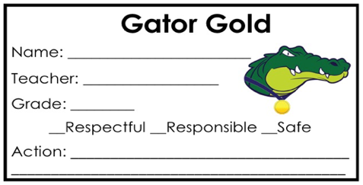
Julius West
Maddox Franklin
Addy Bolin
Jaret Rodriguez
Isaac Price
Reese Blackwelder
Ziyahh Black
Jakhi Chambers

