Greetings Allisonville Alligators! September 11, 2020

What a great day at Allisonville! We had the Re-dedication Ceremony and Ribbon Cutting Friday at noon. Dr. Woodson, members of the School Board and even our former principal, Mr. Pomerenke were present! Due to social distancing, unfortunately we could not invite our entire community but we did video record the ceremony and are happy to share the link to the Ribbon Cutting and also a virtual tour of our newly renovated school here: Ribbon Cutting & Virtual Tour of AV Teachers and staff were able to socially distance in the parking lot so we could all celebrate the ribbon cutting together. Please enjoy some pictures of the ceremony as well.

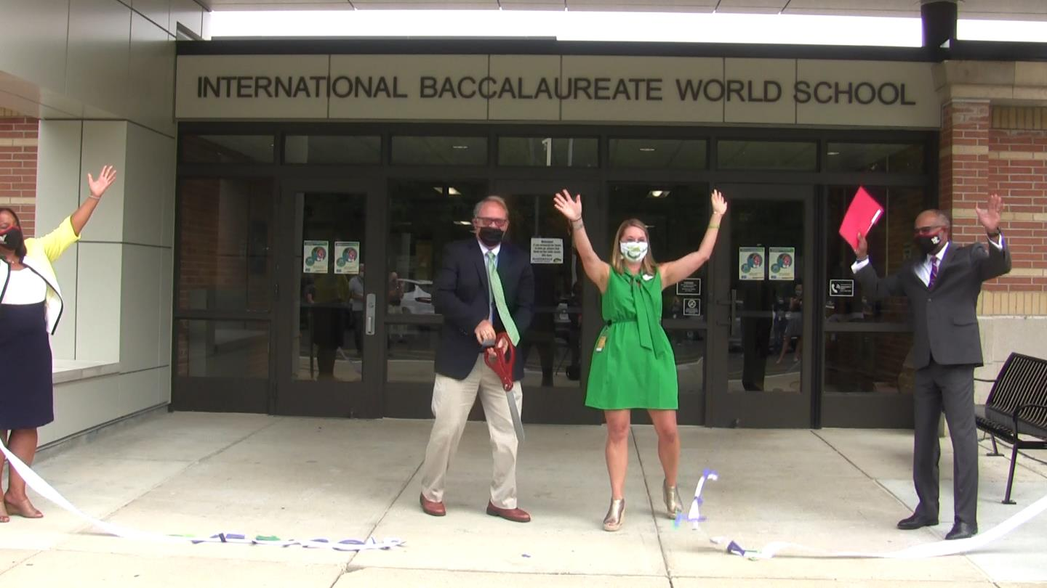

Don’t forget that our Scholastic Book Fair is open and continues through next Tuesday, September 22nd. Mrs. Weiger was able to highlight several of the books that students can purchase during her media lessons this week. Look for additional information in the Gazette on how to order from the Book Fair online. Items will be shipped directly to your home – it is that easy! Additionally, students can continue to check out library books online with pick up at Allisonville on Wednesdays and Fridays. Happy Reading Gators!

Additionally, AV Spirit Wear and last year’s Yearbook are in and ready for pick up. Pick up for these items will be next Wednesday, September 16th and Friday, September 18th from 11:00-1:00 in the afternoon. Just pull up to the front doors at Allisonville and the items will be ready on a table outside. If you ordered Spirit Wear early this fall or if you ordered a 2019-20 Yearbook last year please come by school next week. If the pick-up times do not work for you, just call the office and we will arrange another time.
(continue to next page)
Virtual Afterschool Clubs will begin at Allisonville starting next Tuesday, September 15th from 3:00-3:45. All clubs will run for 6-weeks on Tuesday afternoons. They are free of charge and will be held via ZOOM. Sign up is due by Monday, 14th September using this link: Virtual Club Registration. The clubs include: Book Club, Craft Club, Imagination Chapter, Yoga Club, Allisonville’s Got Talent, and Exercise/Dance Club. Don’t miss up on the fun – sign up today!

A great big GATOR THANK YOU to the entire community and especially the AV PTO for your support of the renovation at Allisonville that was celebrated on Friday. Enjoy this picture of the staff doing the “Gator Chomp”. WE ARE AV!

Mrs. Reffett
Principal

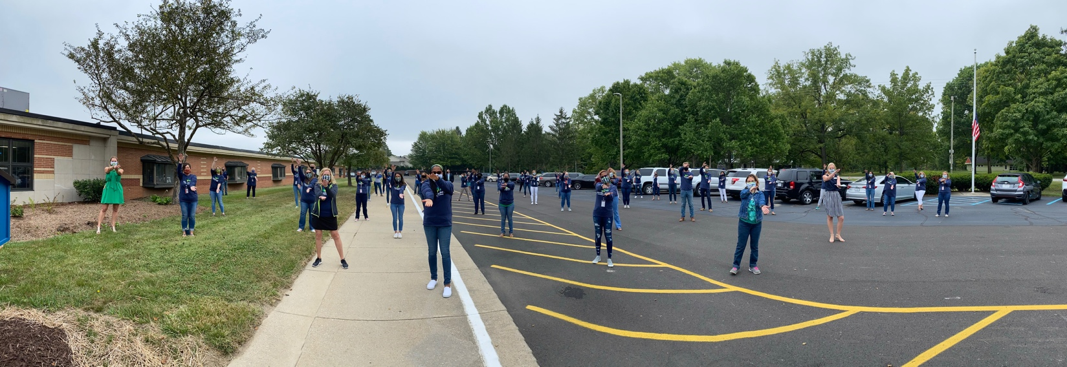

Mark Your Calendar for these Upcoming Dates
- Tuesday, September 15: Virtual Clubs Begin
- Wednesday, September 16: Spirit Wear and Yearbook Pick Up 11:00-1:00
- Friday, September 18: Spirit Wear and Yearbook Pick Up 11:00-1:00
- September 21-25: Spirit Week with Dress Up Days!
- Tuesday, September 22: Book Fair Ends
- Thursday, September 24: Early Release at 2:15 pm
- Friday, September 25: School-Wide Kahoot Game at 3:00

Parent Teacher Organization (PTO) Announcements

- Bingo Night for Adults: Virtual BINGO for AV parents, caregivers, and teachers on Friday, October 16th at 7:00. Silent Auction, prizes, friendly competition, and community building… More details to follow but be sure to save the date so you don’t miss out on the fun!
- NEW Mission Statement: Allisonville PTO is a nonprofit parent teacher organization whose mission is to provide opportunities for parents/guardians and students of different backgrounds to participate and connect through various programs within the school and school community. Working with the school’s leadership, we provide support to student programs, staff and the school community both through grants and volunteerism to benefit our students.
- NEW Vision Statement: Allisonville Elementary PTO aspires to create an inclusive and supportive community for all families and teachers.
- Questions for the PTO? Contact us at: allisonvillePTO@gmail.com

Register to Vote

Election Day is on Tuesday, November 3rd.
You can easily register using this link: https://indianavoters.in.gov/
Be sure to exercise your right to vote!

Reopening of School in MSDWT

Thank you for carefully reviewing the following information and completing the new reopening enrollment process based on the current WT Reopening of Schools for In-Person Learning Plan. This information will help us with vital planning and preparation while we await the Board approved COVID-19 data threshold for returning to in-person learning to be met per the plan.

Here are answers to many of the questions that were asked about AV specifically: Re-entry Q&A . A full reopening play can be found on the MSDWT Website.

Ribbon Cutting Photos
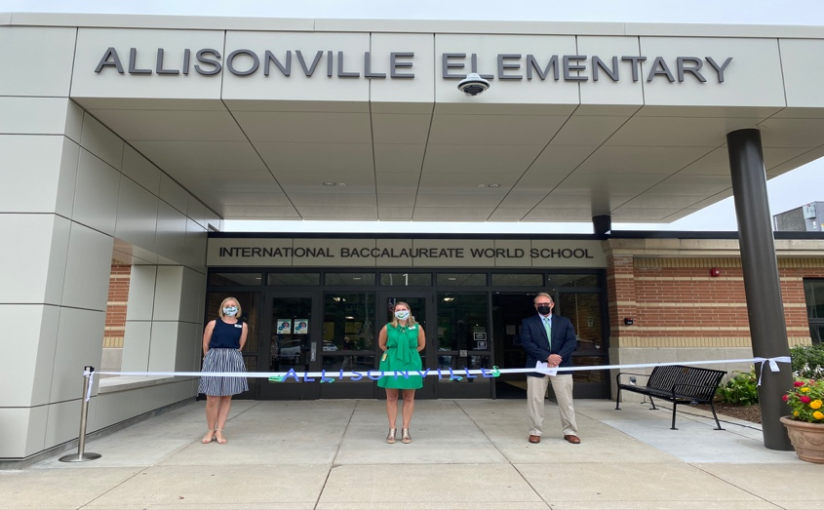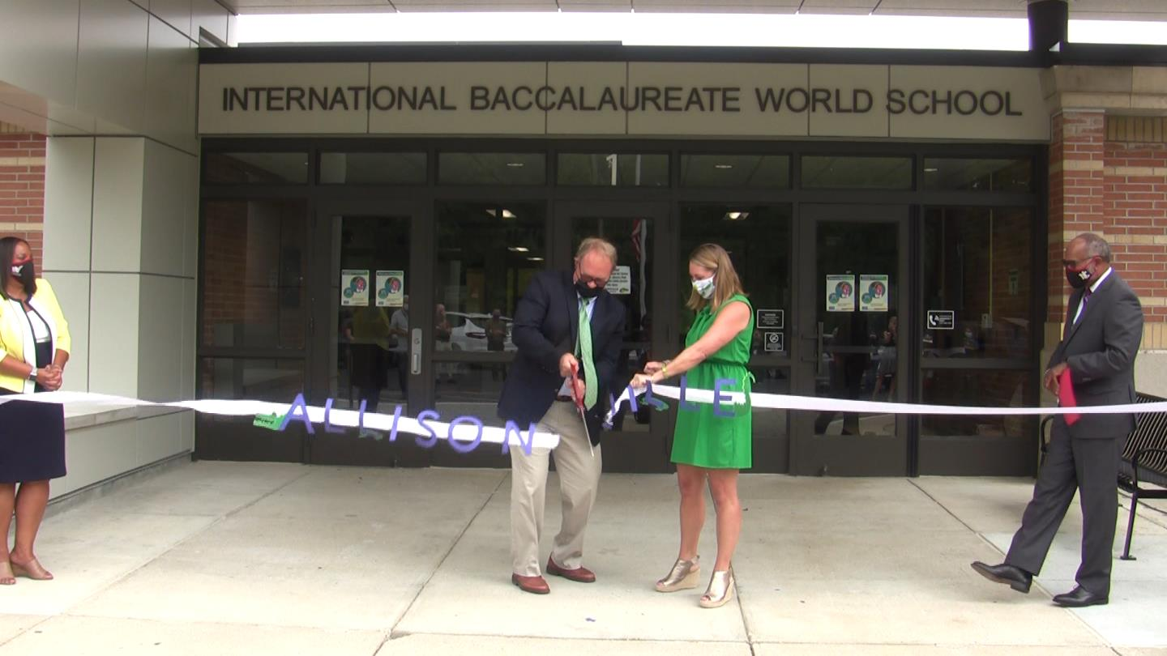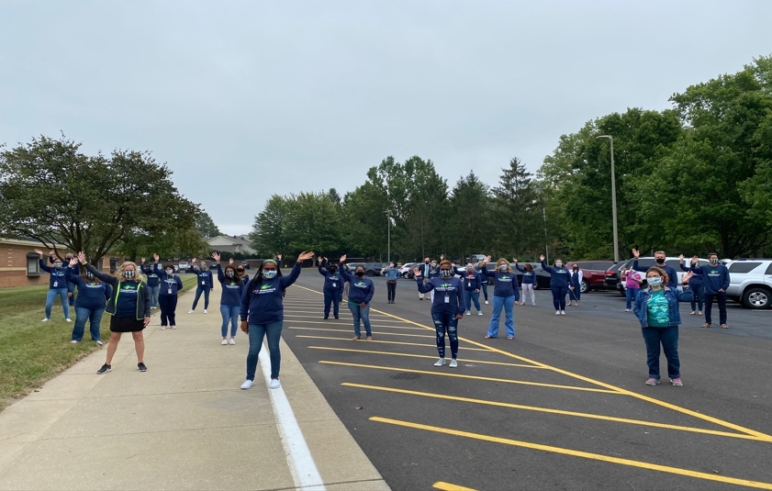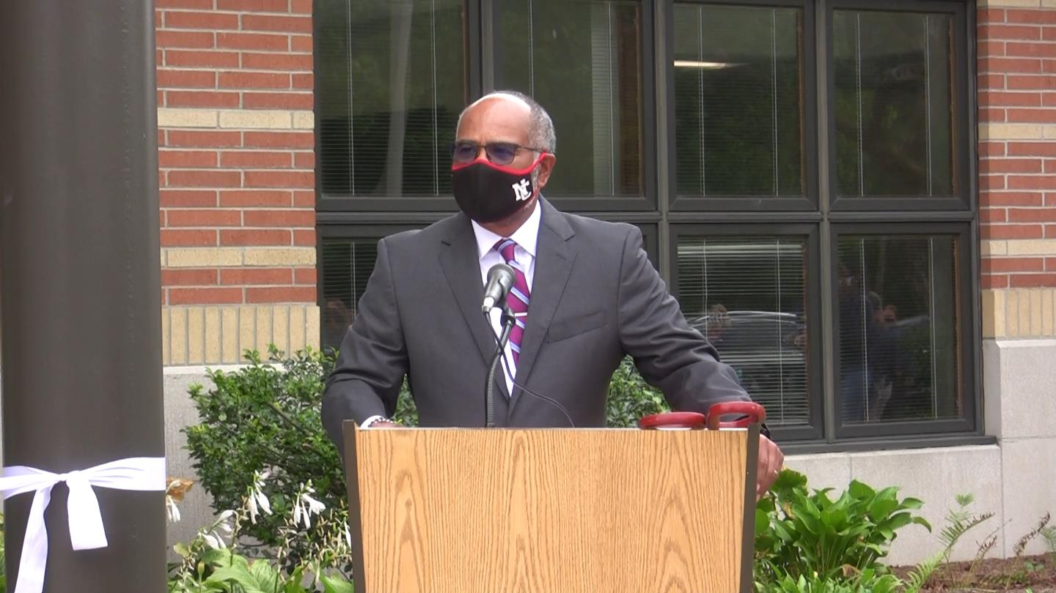
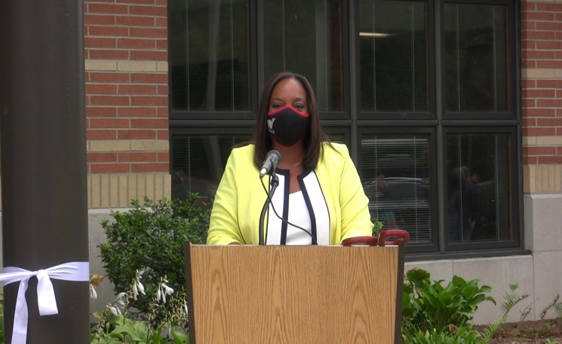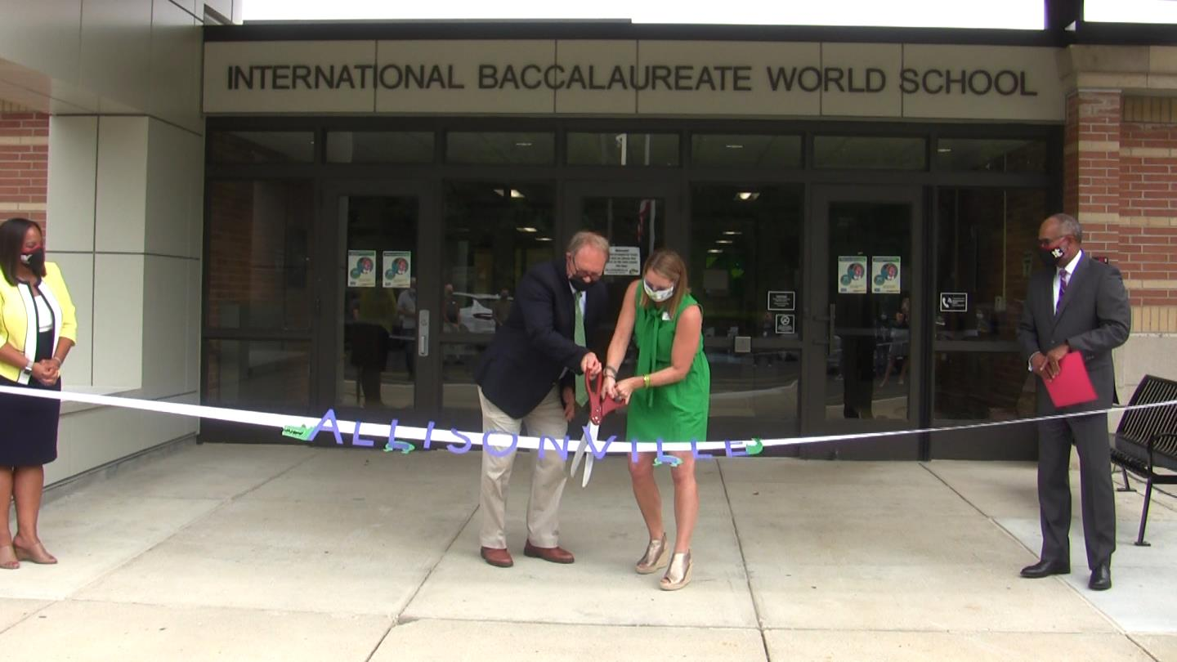
Good news! Allisonville has subscribed to a fun, new reading program that you and your child can access from home! Scholastic BookFlix is an online literacy resource that pairs classic video storybooks from Weston Woods with related nonfiction eBooks from Scholastic to build a love of reading and learning.

To access Bookflix:
Go to Bookflix login page or https://digital.scholastic.com/site/launch/bkflix?ucn=600054245
Username: aville password: 1234

You’re invited to shop our Scholastic Book Fair online from Sept. 9 – 22, 2020! All purchases benefit our school and connect kids with new books, favorite characters, complete series, and more.
You’ll love the NEW option to shop for Book Fair exclusives directly from the interactive booklist and enjoy these special online shopping features:
- Over 6,000 items, including new releases, best sellers, and value packs
- All orders ship direct to home
- FREE shipping on book-only orders over $25*
- All purchases support our school and earn 25% in rewards
Visit our Book Fair Homepage and click “Shop Now” to get started:
https://scholastic.com/bf/allisonvilleelementaryschool
Happy reading,
Mrs. Weiger
Congrats Gator Gold recipients for being RESPONSIBLE this week!

Kindergarten
Arya Ellrich
Jamir Burnett
Laila Amos
Beatrix Hensley
Lauren Johnson
Destin Bullock
Graham Wilkerson
Christian Dilworth
Joshua Larner
Mary McCarney
Christian Preer
Logan Boyer
Cecilia Kaschner
Rileigh Reed
Lynnox Sparks
Etta Morgan
Anaya Green
Claire Ellrich
Caleb Grimm

First Grade
Marvelous Atabong
Luke Killigrew
Margot Killingbeck
Avery Meares
Thais Contreras
Jack Amos
Quinn McFarlan
Kate Riggers
Umaija Warda
Noli Peters
Caroline Lickliter
Cora Cashburn

Second Grade
LaRon Wiggins
Isla Griffin
Karl-Andy Jean
Carson Walters
Calvin Sauer
Walter Lynn
Lili Kennedy
Abe Goldburg-Williams
Luke Amos
Jaden Johnson
Eliise Chambers
Hudson Henhapl
Marin Sickinger
Owen Whaley
Jackson Wahl
Maeve Tuason
Serene Maaite
Madeline Nash
Charlee Jackson
Asher Hill
Cora Deardorff
Hadley Brezette

Third Grade
Charlie Skiles
Samia Wade
Moncerrath Rodriguez-Carbajal
Mia Surrett
Clara Berger
Amarah Manning
Emmie Kuebler
Evie Chaffins
Ari Ajayi
Harmonie Preswood
Kyle Killigrew
Carter Edde
Quinn Matthias
Jack Ekwall
River Kang-Innie
Kyle Killigrew
Leigha Meriweather
Natalie Duncan

Fourth Grade
Alaya Clemmons
Hanna Canady
Laila Brown
Parker Brezette
Avery Bellamy
Molly Auer
MiKayla Shelton
Mateo Hernandez
Jayden Triplett
Lauren Stover
Sophia Rodeheffer
Keane Siparsky
Madisyn Przybylski
Jacen Pate
Javier Lara Rodriguez
Anaya Johnson
Layla Arberry
Yarely Bello-Soriano
Ryan Franklin
Ja’Myen Whitney
Andrew Harris
Avanell Roberts
Aliyah Montgomery
Brody Ditzenberger
Lauren Alkire
Yassir Chouimi
Elle Siparsky
Seth Haffner

Fifth Grade
Maddox Franklin
Brian Meals
Addy Bolin
Phineas Hewlate
Leah Kiefer
Addison Barnhart
Emmett Kaufman
Guadalupe
Tlaxaltecatl
Caden Mejia-Alvarez
Paityn Weiger
Tessa Eynon
Zane Winings
Reid Wilmes
Helen Treadwell
Ezekiel Ramirez
David Smith

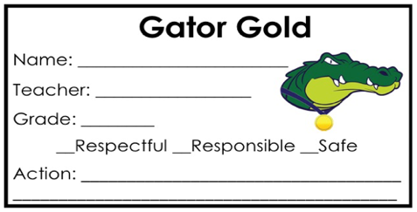

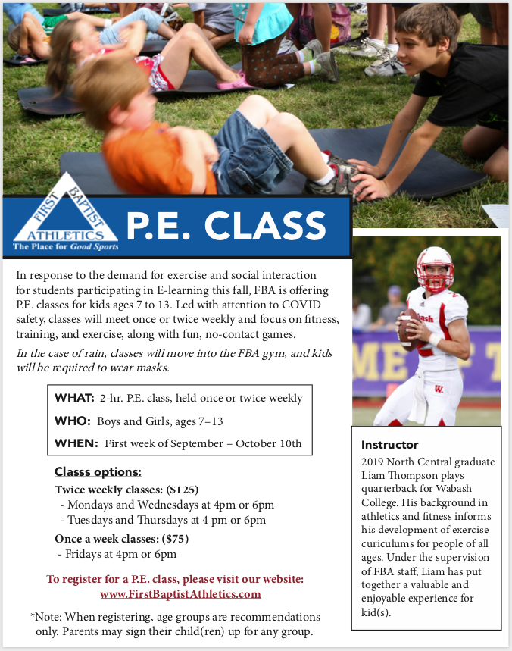

MSD Washington Township/Indianapolis Public Library Card Initiative
MSD Washington Township is proud to partner with the Indianapolis Public Library to have every student receive a library card! This partnership provides an opportunity to create seamless learning opportunities for all of our students who might need to use their library card to access electronic resources to support their class curriculum. Please click on the appropriate link to learn more about this great opportunity.
INDPL letter to parents[2].docx
INDPL Letter Spanish[1].docx
Details and process for each student getting an Indianapolis Public Library card:
- If you want your child to have a library card…just wait for the library card to arrive at the school and be distributed to your child. Here are some details regarding student cards:
  - If a student already has an active library card, the card will just be updated.
  - If a student has never had a card, he/she will receive a new library card that will give full access to all E-Resources as well as limited access to physical material.
  - If a student has had a library card but it has expired, and if there are no fines on his/her account, the card will be renewed and only the number will be provided.
  - If a student has had a library card, and there are fines of $5.00 or more on their account, the card will be renewed and his/her number will be provided to allow access to online material. They will also be enrolled in the library’s Earn and Learn Program. This program allows students to get out of debt by reading down their fines. Students will still be able to borrow a limited number of physical items and will have full access to all E-Resources. Additional information about the program is available at The Indianapolis Public Library.
- If you DO NOT want your child to have a library card, complete the OPT OUT form on the next page by September 16, 2020 and return it to your school.
- Student library cards will be processed after September 16 and distributed later in the Fall to schools. Schools will then distribute the library cards to students.

INDIANAPOLIS PUBLIC LIBRARY CARD OPT OUT FORM
If for some reason you do NOT want your child to receive a library card from The Indianapolis Public Library, please complete the OPT OUT information below and return it to your child’s school by September 16, 2020.
Please do not issue The Indianapolis Public Library card to my child.
_______(x) I do not want my child to have his/her own library card
Name of Student ________________________________________________________(please print)
Grade: _________________ School: ____________________________________________
Parent/Guardian Name(s): ___________ ____________________________________________
Parent/Guardian Signature(s): _____________________________________________________
Date: __________________________

